CSDA1020
Big Data Analytics Tools
Project 2, Apache Spark SQL

S.E.A.L. Cars
Analysis Report

Created: Lancey Abraham, Susiette Adams, Eugene(YongGeun) Park, Anthony San

Table of Contents
- Introduction 2
- Loading cars data into Zeppelin 2
- Checking loaded data’s schema to be able to make SQL queries 2
- Correcting the data types 3
- A SQL query to determine top makers with highest mileage 3
6. A SQL query to determine top makers with resale value 4
7. Running the average price query again but with makers that are top 10 in mileage 4
8. Rnning queries to see if there are specific models that stand out for Volvo and Honda 5
9. This is to analyze best model in Honda. 6
10. Viewing price and mileage by fuel type 6
11. Is there a relationship between make, model and price? 7
12. Does Fuel Type have an impact on price? 7
13. Cleaning the data 7
14. Conclusion 7

- Introduction
The Firm decided that their next business venture would be in used cars. To enter into this new market we had our data scientist analyse data that was collected in Germany, and Czech Republic since 2015. We plan to invest in dealerships within Eastern Europe. Some of the sources provided unstructured data, so as a result the data is dirty. There are missing values and some values are very wrong. For example phone numbers have been inputted as mileage in some cases. The data is consist of roughly 3.5 Million rows and sixteen columns: maker, model, mileage - in KM, manufacture_year, engine_displacement, engine_power, body_type, color_slug, stk_year, transmission, door_count, seat_count, fuel_type, date_created, date_last_seen, price_eur. The data scientist used Zeppelin a derivative of Apache Spark SQL, to analyse the data.

- Loading in car.csv data into Zeppelin.

- Checking loaded data’s schema to be able to make SQL queries.

- Since the datatypes are all strings, we need to convert them to the correct datatypes

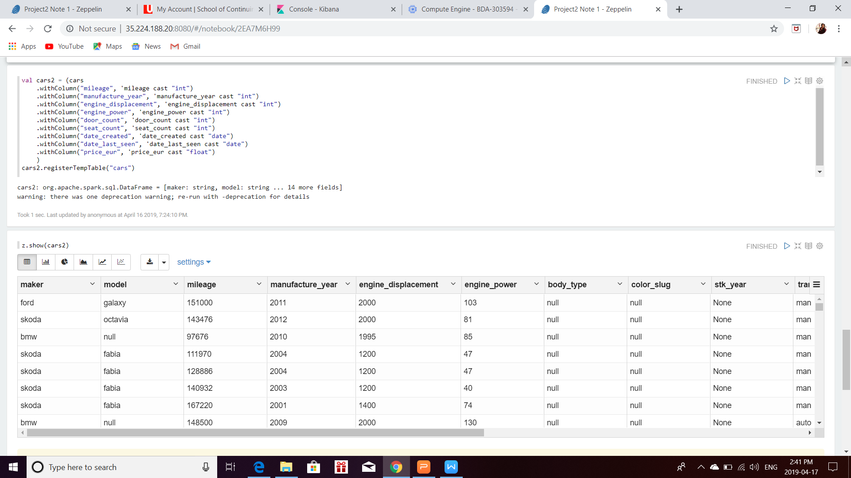

- A SQL query to determine top makers with highest mileage, while excluding entries that have no maker (null) value.

- A SQL query to determine top makers with resale value, while excluding entries that have no maker(null) value.

As it was noticed in Hive analysis, I am noticing some makers that have unrealistic average resale prices. For example, Renault, BMW and Subaru have more than 1 million Euro average resale prices. In addition, some luxury makers, such as Lamborghini & Bentley have 6-figure resale value, which is not fit for this exercise.

- As a result, I am running the average price query again but with makers that are top 10 in mileage. Those makers are Chrysler, Skoda, Alfa-Romeo, Volvo, Honda, Land-Rover, Ford, Volkswagen, Rover and Mazda. Then I am adding average mileage back in, so both price and mileage can be viewed at the same time.

- Top 5 in price are Rover, Honda, Volvo, Mazda & Ford.
- Top 5 in mileage are Chrysler, Skoda, Alfa-Romeo, Volvo and Honda.
- Based on this result, Volvo and Honda are two makers who are in top 5 in both categories.

- Since Volvo and Honda are identified as solid contenders, I am running queries to see if there are specific models that stand out in those brands. This is for Volvo.

- For Volvo, V40, C70, V90, S80, and 440 are top 5 models in price category.
- C70, 440, 740, 940, and 850 are top 5 models in mileage category.
- C70 and 440 are the models that were capture in top 5 in both categories.

- This is to analyze best model in Honda.

- NSX, CR-V, HR-V, S2000, and FR-V are top 5 models in price.
- Stream, Shuttle, FR-V, HR-V, and Integra are top 5 models in mileage.
- FR-V and HR-V are the models that are seen in top 5 in both categories.

- Now I am viewing price and mileage by fuel type. And excluding rows that have null value in fuel_type field.
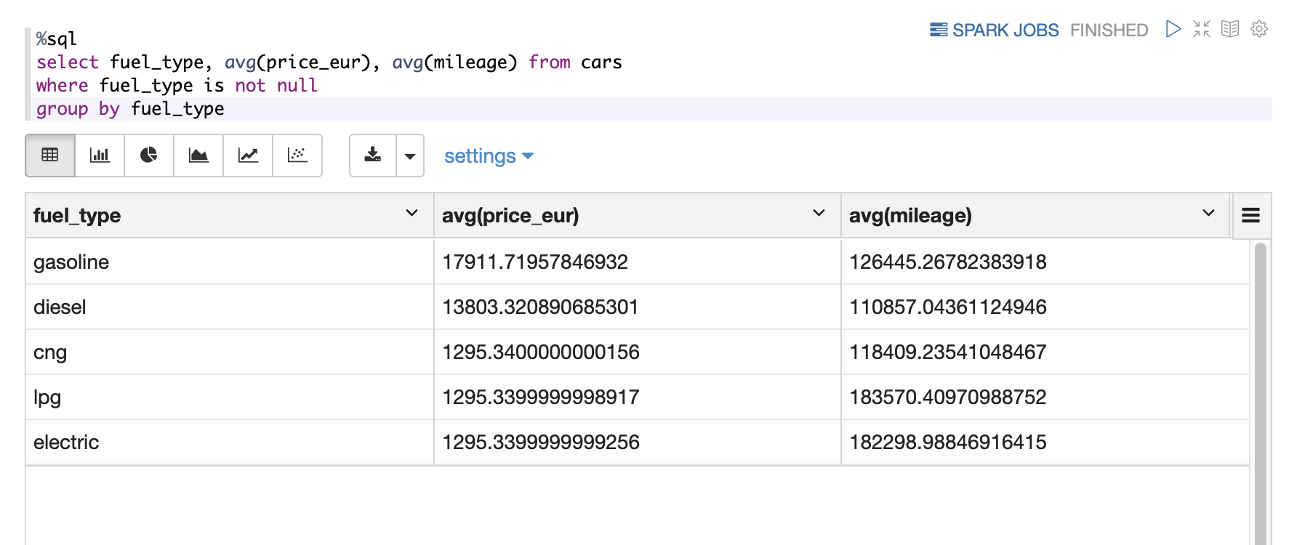

While the result is available, I am not entirely sure if this is a legitimate analysis because CNG, LPG, and Electric vehicle’s resale prices are very distant from Gasoline and Diesel vehicles’.

Although Gasoline vehicle’s both price and mileage are advantageous from Diesel’s, it is known that Diesel is lower in price and has better mileage. That explains why there is demand for Diesel vehicles although Gasoline vehicle have higher monetary value when it comes to resale market.

- Is there a relationship between make, model and price?

There is definitely a relationship between the 3 variables they are all connected and can be dependant or independent variables in some cases for the analysis. We would not have been able to complete our analysis without including one or more of these variables.

- Does Fuel Type have an impact on price?

The type of fuel does seem to have an impact on the price of the car. In our analysis above gasoline cars seem to have more distance drive with the highest resale value. Disel cars are second in line with driving distance and price. If we are to compare the two gasoline/petrol is much easily to find at a gas station, and some fuel station do not carry deisel as much as gasoline. In the past disel fuel had alot of air pollution concerns than gasoline cars. In the past disel cars were seen as more fuel efficient than gasoline cars, but that has changed because gasoline cars are now built to be more fuel efficient. Electric cars are the best to consider when it comes to air pollution, but they are usually more expensive to purchase.

- Data Cleaning

From the analysis, it was evident that the quality of the data was impacting our analysis. Steps were taken to clean the data by excluding NULL values from the analysis.

- Conclusion

After carefully reviewing and analyzing the cars dataset for the prospective used car business our advice is based on the intention to maximize revenue and profit. Revenue is dependent on car sales and sales is dependent on the value proposition for prospective customers. We have made a judgement that used car customers want reliable cars that also retain monetary value relatively longer than other alternatives. As such, the cars we are recommending are the best candidates to meet those two requirements as shown by the ‘maker’, ’models’, 'mileage' and 'price' analysis. The best choices to invest in would be Volvo or Honda Dealerships. Some of the Volvo models to look at would be C70 and 440 and or Honda FR-V and HR-V as these cars have great mileage and retain resale value. Mileage and resale price were important factors as they can predict profit and customer satisfaction two important aspect when contemplating our next investment.

